WING CHUN KUNG FU SYSTEM

as taught
by

DR. SHIN LIN

Susan Samueli Center for Integrative Medicine
UC Irvine
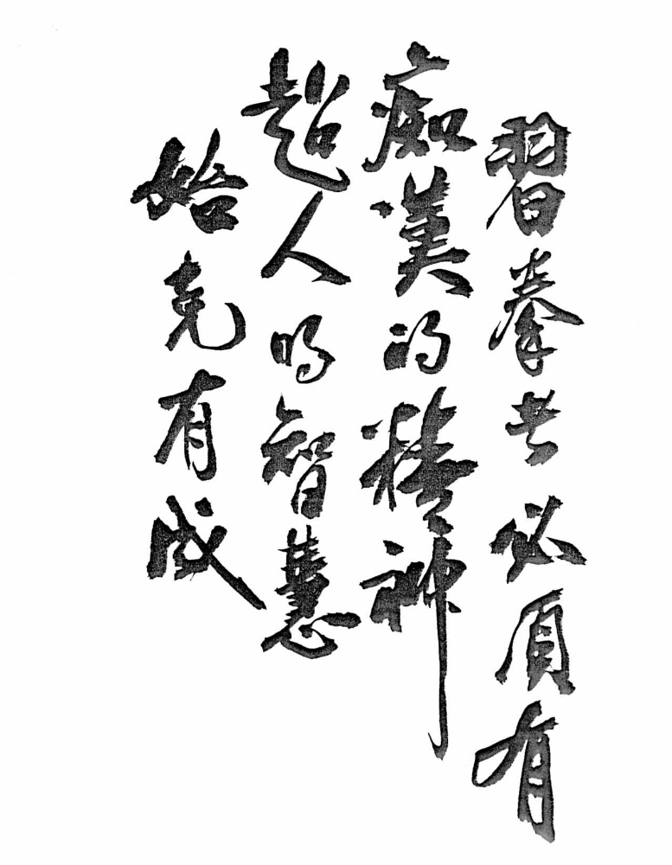
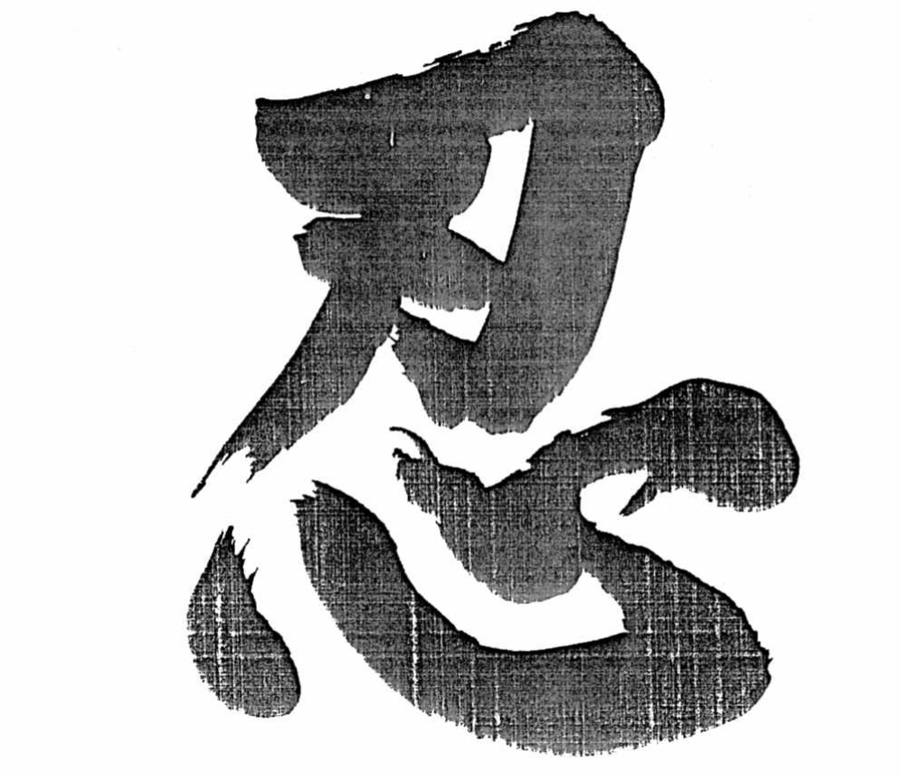

PATIENCE/TOLERANCE

From an old Chinese saying:
"A few unpleasant words not said make you feel peaceful and contented.
Giving way just a little leads to peace in the world".

SPECIAL FEATURES OF WING CHUN KUNG FU

- Heavy emphasis on practical applications.

- System designed so that essential principles and techniques can be learned in a very short time

- Easy to get to a state of high effectiveness, yet lots of "growing room" for years of advance training. Some traditional techniques which are not immediately practical are taught only at later stages.

- Particularly good for beginners without any experience in martial arts.

- Great starting point for learning other types of Kung Fu.

- Learning Wing Chun also increases the appreciation of the practical side of other types of Kung Fu

- Combined use of hard and soft techniques.

- Abdominal breathing and chi training are included at the advanced level.

- Techniques are based on scientific principles to overcome opponents of superior size and strength:
- mechanical leverage.
- maximization of pressure, force, kinetic energy.
  - Force = mass * acceleration
  - Pressure = force/area
- economy of movement for maximum speed
- human physiology of bone alignment, muscular function, pressure points.
- use of psychology to deal with opponents.

- Trained reflexes:
- visual stimuli and muscle reflexes.
- touch stimuli and muscle reflexes.
- Bi-lateral (left-right) independent and simultaneous movements.
- use of wooden dummy to develop speed, precision, toughness of muscle/bone, strength.

- Basic striking/blocking techniques are also useful in grabbing-wrestling situations.

- Excellent training for physical fitness, hand-eye coordination for sports, strength development.

- Not physically demanding; no acrobatic moves

- Requires a small amount of space and no special equipment is needed for practice.

- Build mental discipline, self confidence, and comradeship. Good training for mental concentration (refreshing break after long periods of academic studies).

- 15-20 lb. canvas bag filled with mung beans for practice

Warm-up Exercises

- Interlace fingers softly and make figure 8s

- Slow horizontal circles (parallel to floor … both arms at same time)

- Breastbone shrugs (fingers on sternum… roll shoulders)

- Windmill arms (one side at a time)

- 8 Direction arms

- Arm swing to opposite shoulder/hip

- Waist Turn (soft then harder)

- Warm hands. Place on kidneys and rotate hips

- Bow/arrow lunge – stretch hip flexors

- Bow/arrow lunge – stretch Achilles on back leg

- High lateral side step to stretch hip

- Knee circles – wide stance

- Knee/ankle circles – feet together

- Hamstring stretch – side, side, center

- Squat with arms straight out

- Come up 1/2way and massage kidneys

- Ankle circles

- Knee “spring” kick

- Eye exercises

- Triceps push ups

- Numeric punch drill

- Optional: vertical jumping jacks

- Optional: bent-knee sit-ups

- Pek Gwar

Wing Chun Numeric Punches Principle

The Wing Chun vertical punches (noy moon choie) are designed for close distance power strikes, using the elbow and triceps muscle to achieve maximum acceleration to knock down the opponent's defenses. The fists must be vertical, wrists straight, and elbows must point down towards the ground. Your fist should land with the last three knuckles only. Always maintain proper bone alignment. The punch must be thrown from the center of your chest (joam sien) with your body backing up the punch. Always position your second punch with the other hand near the elbow for instant release. The punches should appear to rotate over the top of each other. While practicing the drill, you do a numeric count of 1 to 5, repeating each number. This is a 15 punch set. Keep a bend in the elbows until contact is made to prevent hyperextension of the joints.

Tai Jung Principle

Always watch your opponent's elbow. The elbow moves 4 times slower than the fist in a circular path and 2.5 times slower in a straight path. Always watch, block, and control the elbows.

The Central Line Principle (face the attack)

First, draw an axis from the top of your head to your feet through the center of your body, dividing the body in half. From one point on this axis to the point of contact with your opponent's striking arm/hand is the "central line". Central lines must be within the area a person, without pivoting his hips, can cross his wrists at the lower, middle, and upper gates. Therefore, your upper body has to be facing the direction of the attack in order to use the central line defense. Blocking on the central line gives you maximum control of incoming forces and thus provides maximum safety from the attack.

The Center Line Principle (attack back)

Again, draw the axis from the top of your head to your feet through the center of your body, dividing the body in half. From one point on this axis to the corresponding point on your opponent's axis (e.g., chest to chest, chin to chin) is the "center line". This center line gives the minimal distance between you and your opponent for striking purposes. Therefore, attacking on the center line allows the quickest response and acceleration to the target. Note that the center line and central line do not overlap under most circumstances; in a simultaneous defense-attack move, your block and your punch both travel the most direct route toward their respective targets and will not interfere with each other.

Dai Jong (“on-guard” position)

Always split your opponent down the middle of their body. Feet parallel and about 45° from center line. Lead hand (man sao) high to protect face, elbow in line with knee of lead leg. Guard hand (wu sao) close to elbow of man sao.

Vertical Punches (choie) with Advancing Steps Drill

This drill is to coordinate vertical punches with simple footwork in an advancing situation. Start from the on-guard position, throw wu sao choie (i.e., guard hand), then throw man sao choie (lead hand) while simultaneously advancing the lead foot followed quickly with an advance of the back foot. Repeat this sequence as many times as there is room.

Tai Jung Pak Sao Drill

This drill is for developing your reflexes to watch your opponent's elbows (tai jung) and to block straight punches at the elbow with your palm (pak sao, which literally means ‘slap with hand’). In this drill, the partners are to stand toe-to-toe with shoulders square against each other. One person throws alternating left and right straight punches at chest level and the other pushes the partner's arm back towards the body at the elbow using the opposite hand (i.e., left pak sao to block right choie). With more practice, the left/right punches can be thrown in random to further train your eye-hand reflexes.

Pak Sao Choie Drill

This drill combines drill no. 1 and 2 described above. Partners should be in a parallel stance against each other; i.e., if one person has the left foot forward in an on-guard position, the other should be in an on-guard position with the right foot forward. The first person throws a man sao choie, the other should block with a man sao pak sao, immediately followed with a wu sao choie and a man sao choie with advancing lead foot. Make sure that the lead foot is outside the lead foot of the opponent to avoid wu sao choie from opponent.

Bil Sao Block

Bil sao (thrusting knife hand) is used for blocking a round punch. Fingers should be together and the hand should be slightly cocked at the wrist towards the center line. Use a left bil sao to block a right round punch and vice versa. The target area of a bil sao block is just above the opponent's elbow crease (at the distal end of the biceps muscle). While the pak sao block is designed to push the opponent's arm back to affect his balance and to minimize the effect of his second punch with his other hand, the bil sao block is designed to connect with the sensitive part of his arm (distal end of biceps muscle just above elbow crease) for a disabling effect on the same arm. The more force behind the opponent’s punch, the more it will disable to opponent.

Bil Sao Choie Drill

This drill involves the combination of techniques used in drills no. 1 and 4. In parallel stances, one partner is to throw a round punch with a man sao and the other is to block with a bil sao, followed immediately with a wu sao choie and a man sao choie with advancing lead foot. Again, the advancing lead foot should go to the outside of opponent's lead foot to avoid his wu sao choie and to keep his initial punching hand out of position for a return block.

Footwork for "T" stance

This series of steps are for a temporary retreat (e.g., from a kicking attack), followed by a quick counter-attack, resulting in the exchange of the lead foot in the process.

Principle: When side-stepping, move your front foot behind your back foot to make a "T" stance. Be sure to move half of your body off the center line. In this stance, the weight distribution should be 40% front and 60% back. Note that this "T" stance is different from the familiar "cat" stance used in many kung fu forms. In the latter, the two feet also form a "T", but practically no weight is on the front foot (thus allowing this foot to kick). In the Wing Chun "T" stance, the 40/60 weight distribution gives a much more stable base for the upper body to absorb a hit or to hit back while in this temporary position.

Drill: Start in an on-guard position with the left foot in front. Withdraw the lead foot to behind the back foot, while rotating the latter on the ball of the foot so that the two form a perfect "T" pointing directly forward. From this temporary position, quickly advance the right foot a full step, followed by a small step forward with the left foot so that you end up in the on-guard position again, but with the right foot forward. Repeat steps with the right foot in front.

Gum Sao Block

Gum sao (push down hand) is used to block straight kicks from an opponent's back leg. Because the leg is always more powerful than the arm, you should always get out of the way of the kick before attempting to block it with a gum sao. Your hand should be in the form of a knife hand, with wrist cocked and fingers together. Hit with the lower edge of your palm. The target area is the pressure point 4 fingers' width above the ankle on the inside of the leg. When this point is hit, the pain discourages the opponent from attacking with this leg.

Gum Sao Choie Drill

This drill practices the gum sao as well as the tai jung principle (watch the opponent’s elbows). Note that a kick with the back leg is always preceded by a drop of the elbow on the opposite side. Partners should start in cross-leg on-guard stances (I.e., one person with left foot in front and the other with right foot in front). The kicking person kicks with the back leg; the other person retreats temporarily by withdrawing the front foot behind the other foot to form the "T" stance, while hitting the kicking leg with a gum sao (using wu sao). Immediately after the gum sao, the same blocking hand becomes a man sao choie thrown at the opponent together with advancing steps. Note that in a realistic drill, the kicking person should be wearing shin guards to protect the pressure points on the legs.

Kan Sao Block

This is a blocking technique used against lower low punches or round kicks. The arm goes from a center line position, sweeping down and out in an arc covering about 90°. Most of the time, the kan sao is accompanied by a choie or block with the other hand for a simultaneous counter-attack or additional defense for the upper body.
Kan Sao Choie Drill

This drill is analogous to the gum sao choie drill except that the kicks are roundhouse kicks. The defending partner uses a kan sao with the lead hand and then pak sao with wu sao for additional protection while executing the "T" stance. In this case, the wu sao pak sao becomes man sao choie accompanied by advancing footwork.

Bong Sao Block

This block, used against punches to chest/face, is a trademark of the Wing Chun system. Proper alignment of hand/forearm/upper arm is of utmost importance. In the proper position, the upper arm should be at the same or higher level as the shoulders and the forearm should be extending outward at an angle of about 135° with the upper arm. The hand should be in knife-hand form in line with the forearm, pointing slightly downwards towards the opponent's knee. The height of the bong sao should be such that the opponent's punch is deflected to a level above your face. Note that when one arm is in the bong sao position, the other hand is usually in the wu sao position behind the other forearm for additional protection of the chest area.

Bong Sao Lap Sao Choie Drill

In parallel stances, one partner starts by throwing a man sao choie with advancing half steps. The other partner blocks with a bong sao/wu sao while stepping back half steps with both feet. At the end of this sequence, the wu sao becomes a lap sao (wipe hand), wiping the opponent’s fist hand downwards, while the bong sao becomes a man sao choie with advancing half steps. The other partner reacts by withdrawing his man sao choie to become a bong sao to block. The whole cycle is then repeated over and over.

Bong Sao Lap Sao Fut Sao Drill

The drill is the same as drill no. 2 above, except that the bong sao becomes a fut sao (sideward knife-hand chop) aimed at the opponent's neck. This is a deadly move and should be used with extreme caution.

Basic Wing Chun Shield for Defense

This is an extremely useful technique designed for total protection of all three gates (i.e., lower, middle, and upper body) against fast kicks and strikes by the opponent. In this stance, you do (a) a bil sao with one of your hands to protect any strikes to your face, (b) a wu sao to protect your chest and middle body, and (c) raise your knee (on the same side as your bil sao) to lower chest level to protect yourself against attack (usually kicks) to any area from ground to chest level or a sweep of your lead foot. It is best if you can use the bottom of your foot to stop kicks. Your bil sao can serve both as a block or a strike towards the opponent’s face.

Shield to Choie Drill

This trains you to block any attacks from the opponent by reflex action, followed by a quick counter-attack with punches. Start by thrusting your hand (bil sao) followed quickly by raising your knee to form the shield. Because you will be standing on one leg in the shield position, you must quickly step forward with the raised leg while simultaneously throwing a wu sao choie and then a series of numeric punches. Offense is always the best defense! Note that when practicing, you should do the bil sao and knee raising as two separate steps. In advanced training, these two steps could be done so quickly that they essentially become a single move.

Tan Sao

This is another Wing Chun trademark. Keeping your elbow in the center, hold your hand palm up, fingers together, with your hand about the same level as your face (your upper and lower arm should form an angle of 135°). Tan sao is for deflecting an on-coming punch away from your body instead of directly opposing the attacking force. This is different from bil sao, which is used mainly to hit the opponent's arm, thus fighting force with force.

Tan Sao Choie Drill

When your partner throws a right straight or round punch aimed at your face, use left tan sao on a central line to deflect while simultaneously throwing a right choie towards his face on the center line. Repeat with the opponent throwing a left punch. Again, use your left tan sao and right choie for simultaneous defense/attack.

Bong Sao Tan Sao Choie Drill

This drill is used to break a front facing choke hold. When an opponent grabs the neck, use bong sao followed by a tan sao choie (same arm) as you sink your weight down and twist to break hold and then counter-attack.

The Neutral Stance

In the neutral stance (similar to the "horse stance" of other kung fu styles), you face your opponent square on, with feet slightly more than shoulder-width apart, both pointing forward. In the Wing Chun style, we emphasize the use of the quadriceps and buttock muscles in this stance, much like a beginning skier plowing down a slope. Note that this stance is used mostly in practice because it is not stable against a push from either the front or the back.

Left/Right Neutral Side Stance

From the neutral stance described above, turn one of your feet towards the side while the other remains pointing forward (left side stance means that your left foot is pointing forward). The advantage of a side stance versus a forward stance is that you are not committing yourself to defend or attack from any particular side when facing your opponent. You can change from a right side stance to a left side stance and vice versa by simply picking up your forward-facing foot and replanting it sideways followed by shifting the side-pointing one to a front-pointing position. With practice, you should be able to change from side to side quickly and naturally. Note that the disadvantage of the side stance is that it is relatively unstable against incoming forces directly from the front and the back.

Kicking from the Side Stance

From the right side stance, shift all of the weight to the right foot, raise the left leg so that the knee is up and close to chest, and kick out using the entirety of the bottom of the foot towards the target. With this type of a kick, your opponent cannot easily catch the underside of your leg or foot (as in a "punter's" kick) and use the force of the kick to lift you off the ground. Note that you can also kick with the right foot by first shifting your weight to the left foot, but the movement is somewhat awkward. You may prefer to quickly shift to a left side stance if you want to kick with your right leg.

Bil Sao, Kick, Choie Drill from Side Stance

Using a right side stance, do a left bil sao and a right wu sao, raise the left knee (similar to shield) and kick with the left leg. After the kick, step down immediately with the left foot so that you are now in a left front stance (similar to on-guard position). Follow up with a left-right choie. Repeat on the other side.

Huen Sao (circular hand)

Huen sao allows you to get from one side of your opponent's hand/arm to the opposite side by rotating your hand (clockwise with the left hand and counterclockwise with the right hand) with only a minor movement of the elbow and upper arm. As a defensive move, the circular movement of huen sao can "dissolve" the on-coming force of the opponent's strike. The huen sao puts your hand in a position more advantageous for a counter attack.

Huen Sao, Choie Drill

Partners facing each other in a right side stance make contact with the right outside wrists/lower forearms (the other hand in wu sao position). One person then does a right huen sao, which changes to a man sao choie towards the opponent's face with advance of the foot on the same side. Note that huen sao can be used against an attack from either hand by the opponent. Repeat on the other side.

Fok Sao (lying hand)

In this technique, your elbow should be at the center line, forearm bent at about 135°, wrist cocked at 90°. Use fok sao to deflect punches by moving the entire arm from center to side without significantly changing these angles. Do not press down on your opponent's arm/hand as this will leave your face open to attack. The bend at the wrist is used to trap the opponent’s arm/hand so that it cannot easily pull back or change to a huen sao. Always keep your elbow pointing down and at center for maximum protection of your chest area.

Fok Sao (lying hand), Huen Sao (circular hand), Jeung (striking palm) Drill

Partners start by facing each other with a neutral side stance. One person throws a right straight punch; the other deflects with a right fok sao, changing to a huen sao, and then to a jeung, stepping forward and aiming at the lower abdominal/diaphragm area. Use a left pak sao to control the opponent's elbow to prevent a counter-attack.

Jut Sao (jerk arm)

From a wu sao or fok sao position on the center line, drop your lower arm quickly until your lower and upper arm form a straight line pointing outward and downward towards your opponent. Jut sao is for a quick block of an opponent's punch to the center, setting up a rapid counter-attack by going from a jut sao to a choie towards the opponent's chest or face.

Jut Sao, Choie

Partners face each other using a neutral side stance. One person throws a left straight punch and the other deflects with a right fok sao, followed by a jut sao and then a choie. The opponent defends by withdrawing the arm to form a bong sao to deflect this incoming choie.

Introduction to the Sil Lim Tao Form (small thoughts)

This form is designed for the training of (a) breathing, (b) concentration, (c) coordination of mind and body, (d) balance, and (e) independent movement of the limbs and body. Since all of the basic strikes and punches learned up to this point are contained in this form, practicing the form will help you remember and perfect the execution of all of these important moves.

Throughout this form, the practitioner is required to have full concentration. His eyes should look straight ahead with his tongue touching the upper plate of his mouth. With his mouth closed, he should breathe normally through his nose. When he uses his palm, he should pack his fingers together and tuck his thumb in so that they are protected. Similarly, whenever he uses his fists, he should first curl up his fingers, placing his thumb over the second section of the index finger. When assuming the neutral stance, he should keep his feet slightly wider than his shoulders, with both feet parallel to each other, squatting down slightly, squeezing his knees towards each other while pushing his pelvis forward. In this way, his head, neck, and body should be tensed so that the energy generated from the thigh muscle (the largest in the body), can travel to the upper part of the body.

The Sil Lim Tao Form (make moves crisp and dynamic)

Begin with feet together, back straight, hands at the sides. Raise both arms to shoulder height, clench fists, rotate fists 180°, double elbow strikes. Bend at knees and drop weight slightly. Do double inside circular steps (counterclockwise for the left foot and clockwise for the right foot). Cross arms down left over right, bend elbows and raise forearms until both palms are facing your face, clench fists, double elbow strikes. Left hand first, position elbow and fist on center line, throw a vertical choie. Change to tan sao, to huen sao, to wu sao. Clench fist followed by elbow strike. Repeat with the other side.

Left hand first. Extend hand outward slowly to form a tan sao (fingertips at the level of the eyebrows). Change to huen sao, to wu sao. Pull wu sao back toward your face until six inches away, drop elbow from shoulder height to side of body at level of lower ribs, change wu sao to fok sao and push out until elbow is on center line and wrist is slightly to right of center line. Repeat two more times. Do these moves slowly but with force as a type of isometric exercise for hand-arm-shoulder-chest-back muscles. After pulling back the wu sao for the fourth time, do a pak sao sideways towards the shoulder, pull back towards the center line, and then pak sao forward (jeung) at face level. Change to tan sao, to huen sao, to wu sao. Clench fist to elbow strike. Repeat on the other side.

Left gum sao to left side. Right gum sao to right side. Double gum sao to back side. Double gum sao to front. Raise arms (folded at elbows) to shoulder height. Left arm on top. Double fut sao. Return to folded arm position, but with the right arm on top. Double jut sao to mid-chest level. Double bil sao to face level. Double gum sao in front to waist level. Raise both arms straight up to shoulder height with hands bent downwards at wrist to form double fok sao. Straighten hands, rotate to form double tan sao. Double huen sao, double wu sao, clench fists, double elbow strikes.

Left low pak sao, center pak sao (palm strike), tan sao, huen sao, clench fist, elbow strike. Repeat on the other side. Left kan sao, tan sao, rotate hand, center pak sao (palm held sideways so that fingers are pointing to the left) tan sao, huen sao, clench fist, elbow strike. Repeat on the other side.

Left bong sao, drop elbow to form low tan sao, center palm strike (fingers pointing downwards), tan sao, huen sao, clench fist, elbow strike. Repeat on the other side.

Left gum sao, right gum sao, left gum sao, right gum sao, left vertical punch, right vertical punch (do not withdraw hand after the punch), left vertical punch, double tan sao, double huen sao, clench both fists, double elbow strike. Pull left foot towards right foot until they are together while releasing fists and allow hands to drop to the sides of the body. End of form.

